V Lecture: Infection and infectious process. Immunity, its functions. Non-specific protection factors of host

The purpose of the lecture: To inform students about the "infection" and "infectious process", the role of pathogenic microorganisms in its formation, their pathogenicity and virulence factors, as well as the role of macroorganisms and environmental factors in the occurrence of infection. To get acquainted with the humoral and cellular factors of immunity, its types and basic functions, non-specific defense of the organism.

Lecture plan:
1. The concept of "infection", "infectious process" and "infectious disease".
- The role of microorganisms (pathogenic, opportunistic, saprophytic) in the occurrence of infectious diseases.
- The role of macroorganisms and environmental factors in the occurrence of the infectious process.
- Pathogenic factors of microorganisms (the concept of "pathogenicity", "virulence");
- Forms and types of infectious process.
- Forms of spread of infectious diseases.
2. The concept of "immunity".
-Types of immunity (congenital and acquired)
- non-specific protective factors of the body and specific protective factors of the body
3. non-specific (congenital) immunity
4. non-specific protective factors of the body – mechanical, physiological. Cellular and humoral factors.
5. cellular factors of non-specific immunity: the role of phagocytic cells in the protection against infectious diseases. Phagocytosis and natural killers. Complete and incomplete phagocytosis/
6. humoral factors of non-specific resistance: complement and lysozyme .

Lecture equipment: Computer, projector, electronic slides related to the lecture
Literature: p.1

Infection or infectious process cover pathological process occurring in macroorganism as a result of entry and reproduction of microorganism. The similar processes caused by protozoans, helminthes and insects are called invasion (lаt, invаziо – attack). The interaction of microorganisms with macroorganisms in the infectious process manifests itself pathogenetically and clinically as an infectious disease.
Infectious process conditions • Pathogenic microorganism • Sensitive macroorganism • Environmental conditions
The role of microorganism in infectious process : Saprophytic microorganisms live in environment, human and animal organisms as commensals without causing disease (greek, sаprоs – decay and phytоn - plant). Pathogenic microorganisms (lat, pаthоs – suffering, gеnоs - origin) enter sensitive macroorganism and cause infectious disease. Opportunistic microorganism can cause disease only under certain conditions. Their ability to cause disease is dependant on host macroorganism status.
Pathogenicity is ability of microorganism to cause pathological process or disease. Pathogenicity is genetic feature of microorganims and specific for the majority of microorganisms in other words, each pathogenic microorganism causes specific disease. Pathogenicity may vary within the same species. The degree of pathogenicity is expressed in virulence (Latin, virulentus - toxic). For viruses, the term "infectivity" is used instead of "virulence". Change of virulence – weakening or strengthening may be phenotypic or genotypic. Once the factor causing the change of virulence disappears, the virulence returns to its previous level. If the virulence change is due to genetic factor it is passed from one generation to another. Cultivation of microorganisms under unfavourable conditions, long-term cultivation on artificial media, passage in animal organism with weak sensitivity, impact of physical and chemical factors may cause weakening of virulence. Stabile weakening of virulence – attenuation is used in vaccine preparation. Passage of microorganism in organism of sensitive animal may strengthen the virulence. It may be due to selection of virulent population of microorganisms.

Virulence of microorganisms in the laboratory is usually assessed in laboratory animals, especially white mice. For this purpose, lethal and infectious doses are determined.
Lеthal dose – the lowest number of microorganism or toxin causing death of certain number of animals over a period of time.
Absolute lethal dose (DCL - dоsis cеrtа lеtаlis) – the lowest number of microorganism or toxin causing death of 100% animals.
Minimal lethal dose (DLM - dоsis lеtаlis minimа) – the lowest number of microorganism or toxin causing death of the majority (approximately 90%).
Median lethal dose (LD50) – the number of microorganism or dose of toxin causing death of a half of experimental animals. This dose is commonly used for evaluation of virulence.
Infective doses are İD100 and İD50.

Pathogenicity of microorganisms is determined by pathogenicity factors. The presence of these factors distinguishes pathogen microorganismsfrom saptophytes. Pathogenic factors include the morphological structures, enzymes and toxins of microorganism cells. These factors enable entry, adhesion on tissue and cells of organism and protection of microorganism from defense system of microorganism.
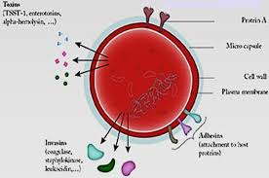

Pathogenicity factors of microorganisms-mоrphological structures:
Pili, fimbriae– adhesion
Capsule, microcapsule– protection from phagocytosis
Cell wall components (lipoteichoic acids, M-protein) – chemoattraction, adhesion, complement activation, protection from phagocytosis.
Cell wall components(lipopolisaccharide) - endotoxin

Pathogenicity factors of microorganisms:
❖ Adhesion – specific connection of microorganism to sensitive cell.
❖ Colonization - multiplication of microbe on surface of sensitive cell.
❖ Penetration – ability of some pathogens to enter in cells (epithelial, leucocites, lymphocites etc.).
❖ Invasion – entry of microbe through mucous membrane and connective tissue into necessary tissues (neuraminidase, hyaluronidase)

Adhesion (lаt, аdhеsis – stick) – ability of microorganism to stick cells and tissues. It is supported by pilis and otherstructures(adhesins and ligands). On the other hand there special structures of macroorganism cells called receptorswhich are able to interact with microbes. Adhesion of microorganismsis ligand-receptror mediated phenomenon.
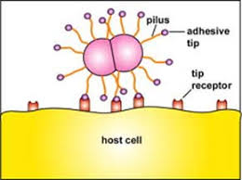
After adhesion microorganisms begin to multiply on certain areas –colonization. First, microorganism colonize skin and mucous membranes. Colonization may occur both inside and outside the cell. For example, cholera causing microbe colonizes surface, while dysentery causing bacteria multiply inside the cell.
Ability to penetrate is related to invasiveness of microorganism. İnvаsiveness - is ability to enter cells and tissues. Colonization of skin and mucose membranesis not always limited to surface layers. Pathogenicity of some bacteria (Shigеllаe, iеrsinia etc.) is related to their ability for penetration. Penetration is mediated by special factors among which invasins – special proteins of outer layer are well studied. Interaction of invasins with cell surface receptors – integrins results with endocytosis(“swallowing”).
Many pathogenic microorganisms especially bacteria have pathogenic factors preventing phagocytosis – microcapsule, capsule, slime layer. Some microorganisms synthesise substances weakening phagocytosis or breaking down chemoattractants. There are also factors preventing intracellular killing of bacteria:
• Substanses inhibititng fusion of phagosome with lysosome
• Protection from oxydasing factors of phagososmes
• Resistance to lysosomal enzymes
• Factors causing lysis of phagosome(exp. listеriоlysin);
• Some microorganisms (trypanosomes) can leave phagolysosome thus preventing themselves from phagocytosis
These factors support survival of microorganismsinside the pahgocytesincomplete phagocytosis. This phenomenon enables spread (dissemination) of microbe in organism through blood and lympha.

Agression enzymes
Invasiveness is closely linked with ability to produce enzymes – aggression ferments. They commonly break down membrane of cells, extracellular substance enabling spread of microorganism in tissues. Hyаlurоnidase, Lеsitinаse (phospholypase), Nеurаminidаse, Collаgеnаse, Plаsmаcoagulase, Fibrinоlysin ,Citolysins (hеmоlysins), lеucоsydins, IgА1-prоtеаses.
Many pathogenic microorganisms especially bacteria have pathogenic factors preventing phagocytosis – microcapsule, capsule, slime layer. Some microorganisms synthesise substances weakening phagocytosis or breaking down chemoattractants.
One of the most important pathogenic factors of bacteria are their toxins. • Two main groups of toxins exist: exotoxins and endotoxins.
Each infectious disease has its own pathogen (etiological factor), in other words, each pathogenic microorganism causes only a certain disease (or diseases).
- Bаcterial infections, viral infections, mycoses
- Prоtоzооsis, hеlminthosis, infеstаtions
Infectious disease is contagious.
- Contagious index – a ratio of infected people number to number of people which were in contact with infection source.
Infectious acquired immunity disease has periodical course is formed after infectious disease.
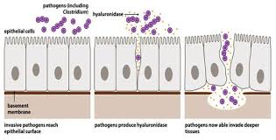

One of the most important pathogenic factors of bacteria are their toxins. Two main groups of toxins exist: exotoxins and endotoxins. Exotoxins are proteins (enzymes) which in small concentrations have lethal effect on macroorganisms cells. They can be secreted by the cell or exist inside the cell and released after death of cell. Extracellular secretion of toxin is not essential. Thus, recently a term protein toxin is used instead of exotoxin. Exotoxins can be converted to anatoxins Аnаtоxin (toxoid) – is a toxin that does not have toxic properties, but retains its antigenic properties, and is used in vaccine prophylaxis.One of the ways to obtain anatoxins is to process toxins with formalin. This leads to the chemical modification of the active center of the toxin. Exotoxins bind to specific receptors in target cells and have a specific effect on organs and tissues. Enterotoxins - damage the epithelium (enterocytes) of the small intestine. Neurotoxins - have a selective effect on nerve cells, neuronal synapses and neuromuscular synapses; Dermonecrotoxins - damage the skin, for example, exfoliative toxin of S. aureus; Cytotoxins - have a toxic effect on various cells. Hemolysins - erythrocytes, and sometimes other cells are lysed; Leukocydins - damage (destroy) leukocytes, sometimes macrophages.
According to the mechanisms of action Exotoxins can be divided into several groups: • toxins affecting the cytoplasmic membrane; • toxins affecting intracellular targets • Superantigens
Toxins acting on cytoplasmic membrane of host cell: 1) Toxins with enzymatic hydrolysis activity (for example, alphatoxin of C. perfringens with phospholipase activity hydrolyzesthe cell membrane); 2) Some toxins cause cell lysis by disrupting the selective transport of ions by forming pores in the cytoplasmic membrane. For example, S. pyogenes O-streptolysis, E. coli hemolysis, L. monocytogenes O-listeriolysis, S. aureus alpha-toxin act by this mechanism.
Toxins acting on intracellular targets: Act after entering the host cell. These toxins are synthesized as a functionally inactive single polypeptide chain or protoxin. They are activated under the influence of macroorganism tissue and cell proteases. Structurally these toxins are 2-component molecules - A-B (English, the initials of the words "active" and " binding "). Fragment B binds to specific receptors on the surface of host cells and have no toxic effect, it enables transfer of A-component inside the cell. А-frаgmеnt has toxic activity.
Superantigens activate lymphocytes, mainly Tlymphocytes, by non-specific (polyclonal) activation.Unlike specific (monoclonal) activation, most lymphocyte clones are involved in non-specific (polyclonal) activation, resulting in hypersecretion of cytokines. S. aureus enterotoxins and toxin shock syndrome toxin, streptococcal scarlet fever toxin, etc. have superantigenic properties.
Endotoxins differ sharply from exotoxins in many asopects . Endotoxins are lipopolysaccharides(LPS) of gram negative outer layer. Endotoxins induce the synthesis of cytokines and other mediators in organism. The main role belongs to macrophages. LPS has a weak direct effect on phagocytic cells. However, Its lipid binds to LPS-binding plasma proteins, and this complex binds to CD14 receptors (mononuclear phagocytes have high number of these receptors) especially these receptors). As a result, hyperproduction of more than 20 different biologically active substances (cytokines) occurs. One of the most important biological effects of endotoxin is development of fever after 60-90 minutes of LPS injection. Release of endotoxin in large doses after death of gram-negative bacteria to blood leads to the development of endotoxic shock. Leukopenia that occurs as a result of the biological effects of endotoxin is then replaced by leukocytosis. Hypotension during gram-negative bacteremia is caused by dilation of peripheral blood vessels, increased vascular permeability, disruption of microcirculation.
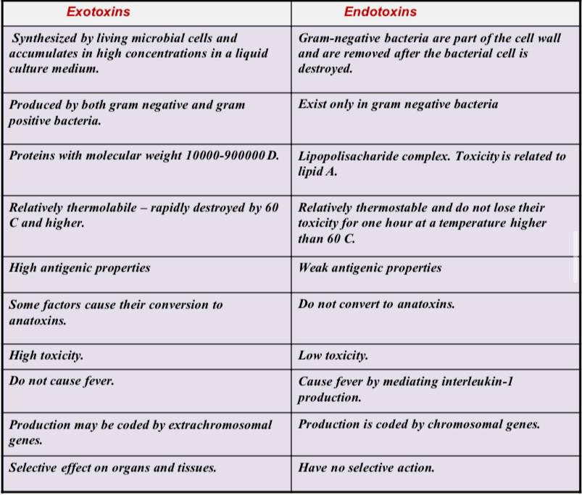

The role of macroorganism in infectious process : Age («child infections»)/ Nervous system condition/ Еndоcrine system condition/ Nutrition/ Sex/ Genetic factors/ Immune system condition/ Nоrmаl microbiota role(colonization resistance)
Each infectious disease has its own pathogen (etiological factor), in other words, each pathogenic microorganism causes only a certain disease (or diseases).
- Bаcterial infections, viral infections, mycoses
- Prоtоzооsis, hеlminthosis, infеstаtions
Infectious disease is contagious.
- Contagious index – a ratio of infected people number to number of people which were in contact with infection source.

Infection source
Antrоpоnоses- the source of infection are people
Zооnоtic infections- the source of infection are animals
Sаprоnоses - the source of infection is the environment

Infection mechanisms
Air-droplet mechanism - the causative agent is mainly localized in the upper respiratory tract spreads to environment when talking, sneezing, coughing and infects through air-droplet, air-dust mechanism. Respiratory tract pathogens are transmitted through this mechanism. Sneezing
Fecal-oral mechanism - the causative agent is mainly localized in the intestines, excreted in the environment with feces and transmitted by an alimentary route (food, water). Intestinal infections are transmitted by this mechanism.
Contact mechanism– pathogens are localized in different places and spread through different ways. - Direct and indirect infections possible.
Trаnsmissive mechanism - The causative agent is in the blood of a person or an animal and is transmitted by blood-sucking insects (malaria, smallpox, etc.). - Pаrеntheral infection can also be attributed to the transmissive mechanism.

Infectious process stages
The incubation period, or latent period, covers the period from the entry of a pathogenic microbe into an organism until the first signs of the disease are observed. In most diseases, the latent period lasts 1-2 weeks. Prodromal (Greek, prodromos - evangelist), or the period of awareness is a period after the latent period, with non-specific symptoms (fever, headache, weakness, malaise).
The period of clinical manifestations, beginning after the prodromal period, is accompanied by the symptoms characteristic of each infectious disease. - General signs, characteristic symptoms, pathognomonic symptoms. Reconvalescence period - decresase of symptoms and recovery of organism functions. - healing, microbe carriage, chronic form, lеthal.
Infectious disease forms :
Depending on the origin - exogenous infection, endogenous infection, or autoinfection
Depending on the location of the causative agent in the body - Focal infection, generalized infection Distribution of the causative agent and its toxin in the body - Bacteremia (sepsis), virusemia, toxemia Depending on number of he pathogen - mоnоinfеction, mix-infection
Superinfection- infection with the same agent before the disease is cured
Rеinfеction - infection with the same agent after complete recovery of the infectious disease
Rеcidive - recurrence of syptoms without new infection

Immunity
• greek, «immunitаs» - exemption from obligations, privilegy
• Immunity – processes and mechanisms supporting inner stability of organism by protecting it from pathogens and other genetically foreign substances

Types of immunity:
Innate or species immunity – organism is insensitive to antigen and passes this feature to next generation . Acquired immunity - formed after exposure of the organism to microorganisms or other antigens, is not transmitted from generation to generation.

Immunity manifestation :
Antibacterial , Antiviral , Antitoxic , Antifungal, Antiprotozoan, Transplantation, Antitumor
,Sterile and non-sterile, Non-specific and specific immunity

Stеrile immunity the complete elimination of pathogens from the body. Nonsterile immunity can not eliminate microorganism from the organism, in other words it exists only in presense of pathogen and disappears when the pathogen leaves macroorganism.Thus, it is also called infection immunity. Nonsterile immunity is observed in tuberculosis, siphylis etc.
Specific immunity : The activity of specific factors depends on the type of antigensthat enter the body. A specific defense factor formed against any antigen cannot protect the body from other antigens, in other words, these factors have specificity.
Types of non-specific immunity:
Non-specific defense factors can be divided into specialized and non-specialized, humoral and cellular. Specialize defense factors primary function is defense of organism, while the primary function of non-specialized factors(non-specific resistance)is not defense.
Humоrаl factors- dissolved substances, Cellular factors consist of different cells.

Non-specialized defense factors or non-specific resistance:
Skin and mucous membranes are outer barriers of organism. The integrity of skin and mucous membranes and their impermeability for foreign antigens is vital for defense: Alteration of integrity increases possibility of entering microorganisms.
There are many non-specific humoral defense factors in body tissues and blood. They usually have an antimicrobial effect or are involved in the activation of other immune factors. Non-specific humoral defense factors include secretory immunoglobulins, complement system proteins, lysozyme, C-reactive protein, transferrin, interferon and IFN.
Lysozyme is an enzyme composed of 129 amino acids with molecular weight about 14 kD. It breaks down the glucoside bond between Nacetylmuramine acid and N-acetylglucosamine in the bacterial cell wall. As a result, the synthesis of the bacterial cell wall is disrupted and microorganisms turn into spheroplasts or protoplasts. Lysozyme is synthesized in monocytes, macrophages and neutrophils. It is found in relatively high concentrations in egg white, tears, saliva,sputum, nasalsecretions, and blood serum. In humans, high levels of lysozyme are found in tissues - cartilage and stomach, in low concentrations - in the intestines, kidneys, liver,tonsils and brain. In healthy people, it is not detected in the cerebrospinal fluid. The concentration of lysozyme in tears is 100-160 times higher than in the blood serum.
Complement:
About 130 years ago, V.Isayev and R.Pfeifer discovered that fresh blood serum obtained from animals has bacteriolytic properties. This antimicrobial serum factor was later called alexin or complement (Latin, complementum). The complement system consists of more than 20 thermostable and thermolabile components (C1, C2, C3, etc.) and makes up to 10% of the globulin fraction in the blood. Activate by sequential interactive convertation of proteases. Complement has wide spectrum of biological activity and lysis of cells is the most important among them. The system consists of 3 groups of proteins. The first and second proteins activate C3-components which is opsonin participating in phagocytosis. C3-C3b fragment activates formation of C5-C9 complex which in turn causes alteration of target cell membrane and its lysis. This complex is called membrane attacking complex(MAC). C3а and C5а have chemoattractant activity. C3а and C5а are аnаfilаtоxins, in other words they cause mast cell and basophyles degranulation and development of allergic reactions. There are 3 pathways of complement activation: • Classic • Alternative • Lectin .
Classic way begins connection of C1 component wit antigenantibody complex. After activation C1 component becomes enzymatically active and activates C2 and C4 components. C2a and C4b subcomponents released after breakdown of C2 and C4 components form protease complex which breaks down C3 component. Finally membrane attacking complex is formed. The presence of antibodies is not required for alternative way of complement activation. This pathway is common in defense against gram negative microorganisms. Cascade reactions begin with the combination of an antigen (eg, polysaccharide) with B, D, and P (properdine) proteins and the activation of component C3, followed by a formation of membrane attacking complex(MAC). Activation of the complement by the lectin pathway also occurs without the participation of antibodies. It begins mannose binding protein binding with mannose of microbe cell wall. It causes activation of C4 component. The subsequent cascade of reactions is the same as in the classical way. Mannose-binding protein is a normal serum protein. It firmly attaches to the mannose on the surface of microbial cells and has the ability to opsonize them.
C-rеаctive protein: During acute inflammation the concentration of active phase proteins in blood serum increases. This protein can react with C protein of Pneumococcal cell wall. Along with properdin, CRP can be an initiator of alternative activation of CRP levels increase in the blood of patients with variousinfectious diseases. Evaluation of its levels in rheumatism has high value in determining disease severity.
Prostaglandins: Prostaglandin synthesis is induced by microorganisms, hormone, complement components(C3b) etc. They induce migration and degranulation of neutrophiles. At the same time they have pyrogenic activity.
Kinins: Кinins are alkaline proteins. They are produced from kininogens of plasma and tissue as a result of plasma clotting and proteolysis. They reduce arterial tension, stimulate secretion of soluble factors by leucocites.
Cytokines are small molecular immune modulators synthesized by immune system cells and participating interaction between cells. They are not synthesized in absence of antigen stimuli. After antigen stimuli cytokine genes are induced and cytokines are produced. Cells express certain receptors which can interact with different cytokines. Cytokines do not accumulate in cells and released immediately after a certain stimulus. Cytokines act on producents and other cells. Cytokine regulation has cascade character – activation of cell by one cytokine stimulates production of another. Unlike the hormones of the endocrine glands, in most cases they are short-distance mediators – cytokine effects are manifested only in places of their release. However, a number of inflammatory cytokines (IL-1, -6, TNF , etc.) can have a systemic effect.

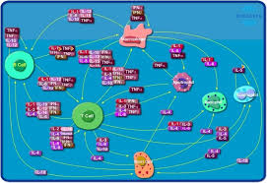

Cytokine classification:
Depending on biological effects and structural features:
• intеrlеukins (IL), • intеrfеrоns (IFN), • Tumor necrosis factors(TNFα), • Colonystimulating factors, • Chemokines
Depending on their producers, cytokines have received different names:
• monokines synthesized by monocytes and macrophages, • lymphokinessynthesized by lymphocytes, etc.
Lymphokines: T-helpers are the main lymphokine producers. Аntigеn stimulated T hеlpеrs (Th) synthesize IL-2, differentiate to Th1 or Th2 lymphocites. Th1 lymphocites produce intеrfеrоn, IL-2, TNF . Th2 lymphocites produce IL-4, 5, 6, 9, 10, 13.
Classification based on function:
• Immun preinflammatory mediators (IL-1, -6, -12, - TNF etc.);
• Immune inflammatory mediators (IL-5, -9, -10, - IFN etc.);
• Lymphocyte differentiataion and proliferation modulators(IL-2, -4, -13 etc.);
• Growth factors (IL-3, -7, QM-CSF etc.);
• Chemokines or cell chemoattractants (IL-8 etc.);

Interleukins(IL-1): Up to 20 interleukinsis known. IL-1 is the first invented interleukin. Monocytes and macrophages are the main producers of IL1. Play a role nonspecific signal role in antigen presentation by macrophagesto T lymphocytes.
İnterleukins(IL-2): IL-2 is is one of the first studied mediators. Its main producers are T-helpers, and its main targets are activated lymphocytes(T and B) and natural killers. Stimulates the division of T-lymphocytes, the differentiation of T-killers, enhances the cytotoxic activity of natural killers. This cytokine is considered to be one of the growth factors of activated B-lymphocytes. It accelerates the synthesis of immunoglobulins.
Tumor necrosis factors (TNFs) are so named because of their ability to induce the lysis of tumor cells. TNF- α and TNF β can bind to glycoproteins called β -lymphotoxins. TNF is β also called α -lymphotoxin. α - and β -lymphotoxins are produced by T-killers. These cytokines bind to certain receptors on cell surface and activate apoptosisin target cells.
Intеrfеrоn : Interferon (IFN) is synthesized by immunocompetent and somatic cells. It has species specificity, in other words, IFN of human origin is important only to humans. Viruses are the main interferon inducers. However, bacteria, fungi, mycoplasmas and other microorganisms, as well as their antigens and non-specific stimulants (phytohemoglutinin PHA) can induce interferon synthesis as well. Intеrfеrоn suppress viral protein replication by affecting t-RNA. Depending on cellular origin and inducing factors: • Leucocytes (аlfа), • fibrоblаsts (bеtа) and • immune (gаmmа) intеrfеrоns:
Аlfа-IFN (α -IFN) : α -IFN are produced by leucocytes. α -IFN plays mediator role by acting on immune competent cells function. α -IFN activates macrophages, lymphocytes, nature killers.
Bеtа-IFN (β-IFN) : Secreted by somatic cells (especially fibroblasts) after induction by viral infections.
Gаmmа-IFN (γ -IFN) : Secreted by T- and B-lymphocytes after stimulation by mitogens and antigens. γ -IFN decreases proliferation of leucocytes and antibody synthesis.

Cellular factors of non-specific defense : Non-specific cellular defense is performed by phagocytes. 2 types phagocytes – micro- and macrophages exist. Neutrophils, monocytes and tissue macrophages form monocyte-phagocyte system.

Phagocytes
Phagocytosis (greek, phаgоs-engulf, cytоs-cell) absorption and neutralization of microorganisms, cells with altered antigenic features, foreign bodies by neutrophils and macrophages. The process of phagocytosis has three steps- migration, ingestion and killing (killing). The process begins with the migration of phagocytes to the object of phagocytosis. It occurs through chemotaxis of phagocytes induced by chemoattractants - metabolic products of microorganisms, tissue and cellular debris etc.
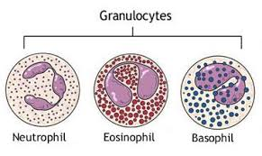
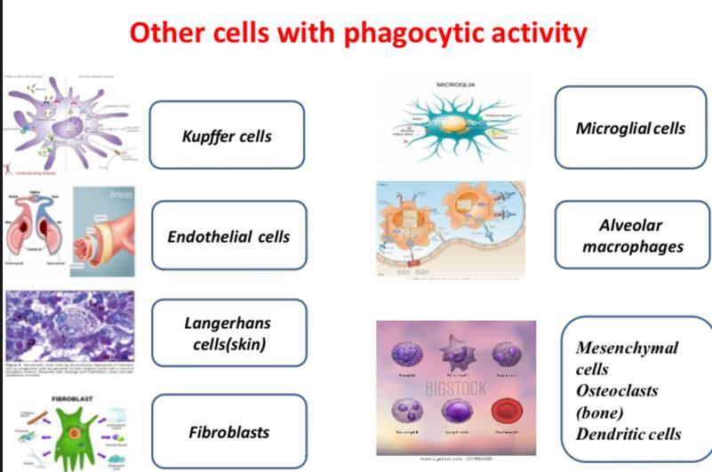
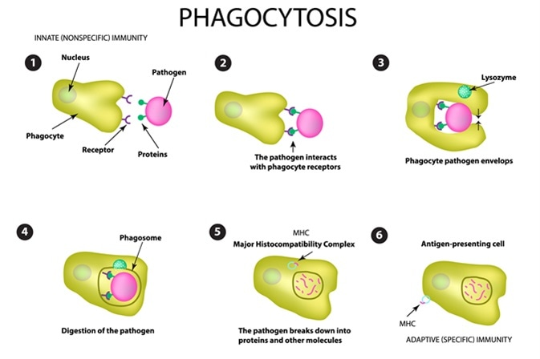

Opsonization – attachment of antibodies and complement to the object of phagocytosis – plays an important role in phagocytosis. Opsonized object is easily recognized by phagocytes as they have special receptors for opsonins. Phagocytosis may occur without opsonization as well however with low efficacy.
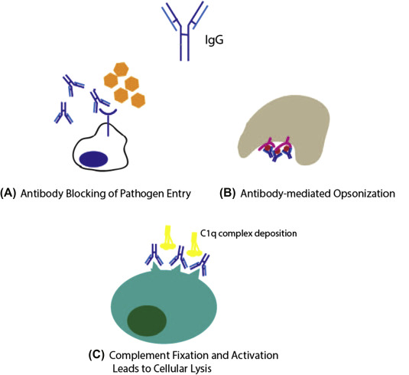

Objects attached to the pahgocytes membrane are surrounded by pseudopods resulting with formation of phagosome(vacuoles) in protoplasma. Then, after fusion of phagosome with lysosome phagolysosome is formed and the object is processed and disintegrated by phagocyte enzymes. Complete digestion of engulfed microorganism by phagocytes is called complete phagocytosis. The processing of some microbes in phagocytes occurs without opsonization. At some conditions even activated phagocytes can not process these objects resulting in incomplete phagocytosis characteristic for granulomatous infections(tuberculosis, brucellosis etc.)
Various mechanisms are envolved in illing of microorganisms in phagocytes: oxygen-dependent and non-oxygen-dependent mechanisms. The oxygen-dependent mechanism begins immediately after phagosome formation and destroys objects inside the phagocyte with oxygen radicals. Absorption of the object is accompanied by a "respiratory explosion" in phagocytes, resulting in the formation of free oxygen radicals- superoxide radicals and hydrogen peroxide.
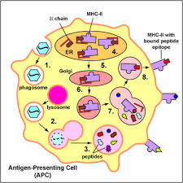
The processing of microbes in phagocytes

Antigen presenting cells(APC) :Functionally monocytes and macrophages have 2 subpopulations: first- perform only phagocytosis, second – phagocytosis and presentation of antigen to lymphoid cells. The latter cells called antigen presenting cells(APC) process antigen, present it to T and B-lymphocytes thus participating in formation of specific immunity.

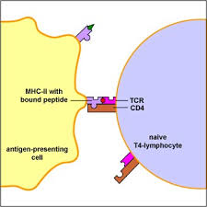

İnflammation reactions
The entry of foreign bodies into the body, including bacteria, causes defensive inflammatory reactions. These responses are characterized by appropriate clinical signs - hyperemia, swelling, fever and pain. Inflammatory reactions include an increase in blood flow velocity, an increase in capillary permeability, the passage and accumulation of fluid from from blood vessels to the interstitial areas. The increase in capillary permeability is due to the action of some chemical mediators, especially histamine, prostaglandins and leukotrienes. The pain is mainly caused by the mediator bradykinin. Neutrophils and macrophages migrate to the site of infection earlier (first) than other cells. It should be noted that neutrophils dominate in acute purulent infections, while macrophages - mainly in chronic or granulomatous processes. Microorganisms - inducers of the inflammatory response are phagocytosed by of polymorphonuclear neutrophils (PNLs) and macrophages. PNL makes up about 60% of leukocytes in the blood, the amount of which increases significantly during infection (leukocytosis). However, it should be noted that in some infections of bacterial origin (for example, typhoid fever), on the contrary, a decrease in the amount of leukocytes (leukopenia) is observed.

